Synopsis

Name / Title of the Project
Doctor Appointment Scheduler

Statement about the Problem
The problem is if we booking any medical appointment, we have to face long waiting times queue, struggle to finding any specialists and often deal with manual scheduling. On the other hand, in the small clinic staff spends hours on managing phone calls, handling cancellation, timing issue and organizing patient records this is led to a huge problem there is a need for a centralized digital platform to automate scheduling, appointments, patient record and time management.

Objective and scope of the project
To build a comprehensive digital platform that allows to find doctors, book appointments, manage payments and records.
The system will feature a searchable doctor with filter for specialization and location. It will handle entire booking flow, including real -time slot selection and a secure online fee collection system. Both patients and doctors will have dedicated dashboard s to track upcoming visits, past history and slot wise appointments.

Methodology
- Search & Selection: The user searches for a doctor and selects an available time slot on the frontend interface.
- Verification & Payment Method: The system calculates pay and checks insurance, and processes the payment before confirming the slot.
- Database Update: The backend books the time slot, updates the doctor's schedule, and logs the transaction.
- Notification & Sync: Automated reminders are sent out, and the appointment is synced to the user's Google/Outlook calendar.

Hardware & Software to be used
Hardware:
Laptop /Pc with Window 11 with 8GB Ram 256 GB SSD i3 Processor
Software:
Window OS, VS Code, Web Browser, MySQL, HTML, CSS, JS ,Strip

Future Work of this Project
While the system handles booking and management. The future versions will integrate full Telemedicine: allowing for live video consultations directly on the platform capabilities, Prescription Management: Allow doctors to issue digital prescriptions, Medical History: Maintain a digital health record for each patient, Mobile Responsiveness: Accessible on all devices and screen sizes, Auto-Refund on Cancellation: Automatically refund patients when a doctor cancels their appointment. and also plan to add a Waitlist Feature that automatically notifies patients if an earlier slot opens up due to a cancellation

The Schedule of the project (Gantt chart/ PERT chart)
Week 1: Planning & Frontend Structure
Finalizing the UI/UX design, setting up the database schema (MySQL), and building the basic frontend pages (HTML/CSS/JS) for the doctor directory and dashboards.

Week 2: Backend Core & Authentication
Setting up the Flask backend, creating the main API endpoints, connecting the database, and getting user authentication (login/signup) working securely.

Week 3: Integrations & Booking Logic
Connecting the frontend forms to the backend logic. Integrating the Stripe payment gateway for fees and setting up the Google/Outlook calendar sync.

Week 4: Testing & Deployment
Running full system tests to catch bugs, handling edge cases (like testing the auto-refund logic), finalizing the documentation, and deploying the platform.

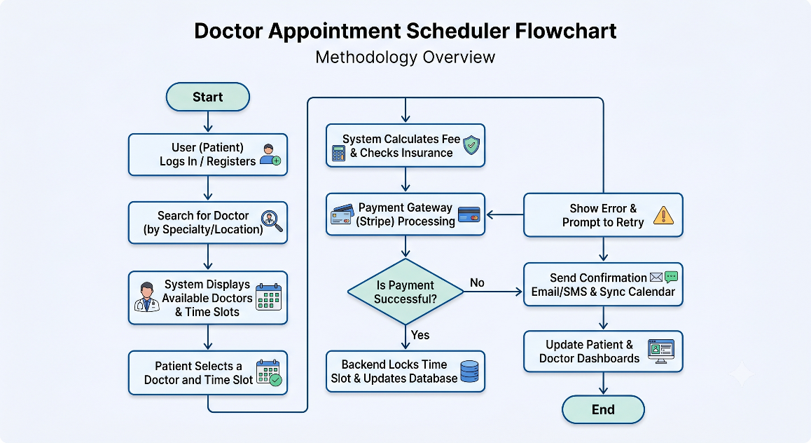

Conclusion
The Doctor Appointment Scheduler significantly modernizes healthcare administration. By automating the booking process, verifying insurance upfront, and handling payments digitally, it eliminates the major friction points of visiting a clinic. It provides a clean, interface for patients while giving medical professionals a robust tool to manage their practice efficiently.

References/Bibliography.
[1] Miguel Grinberg, Flask Web Development: Developing Web Applications with Python, 2nd ed. Sebastopol, CA: O'Reilly Media, 2018.
[2] Stripe API Reference
[3] MySQL 8.0 Reference Manual,
[4] Microsoft copilot

Questions: -.

Question 1: - Explain in at least 100 words the reasons, why should the department approve your project?
Conclusion
This project is of full-stack development applied to a real-world industry: healthcare. It goes beyond a simple database project by integrating complex, real-time features like dynamic scheduling, third-party payment gateways (Stripe), and automated calendar syncing. It requires handling sensitive data securely and managing complex relational between patients and doctors, and ensuring a good user experience. Building this proves my ability to construct a scalable, production-ready application that solves a genuine administrative problem, which is exactly the kind of problem-solving the IT industry looks for.

Question 2: What are the strengths and limitations of your proposed work?
- Strengths: It is highly automated, handles the entire patient journey from searching to payment, and reduces manual admin work. The integration of real-time slot checking and automated refunds makes it very practical.
- Limitations: It requires high security standards since it deals with medical histories and financial transactions. Also, the auto-refund and payment features are dependent on external gateways, meaning any network issues on their end affect our platform.

Question 3: - Explain in at least 100 words what will be the positive impact of the project on society/academics/college/industry.
In the healthcare sector, time is quite literally a lifesaver. This project directly impacts society by reducing the time patients spend waiting in clinics or on hold over the phone. By streamlining the booking and insurance verification process, doctors can spend more time actually treating patients rather than dealing with paperwork and scheduling conflicts. For the industry, it provides a scalable blueprint for how small to mid-sized clinics can digitize their operations without needing to hire massive administrative teams, ultimately lowering healthcare overhead costs.

